**seek() method**

In Python, seek() function is used to **change the position of the File Handle** to a given specific position. File handle is like a cursor, which defines from where the data has to be read or written in the file.

***Syntax:****f.seek(offset, from_what), where f is file pointer****Parameters:******Offset:****Number of positions to move forward****from_what:****It defines point of reference.****Returns:****Does not return any value*

The reference point is selected by the **from_what** argument. It accepts three values: 

* **0:** sets the reference point at the beginning of the file
* **1:** sets the reference point at the current file position
* **2:** sets the reference point at the end of the file

By default from_what argument is set to 0.  
**Note:** Reference point at current position / end of file cannot be set in text mode except when offset is equal to 0.

**Example 1:**Let’s suppose we have to read a file named “GfG.txt” which contains the following text:

"Code is like humor. When you have to explain it, it’s bad."

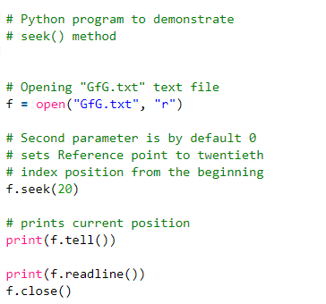

**Example 2:**Seek() function with negative offset only works when file is opened in binary mode. Let’s suppose the binary file contains the following text.

b'Code is like humor. When you have to explain it, its bad.'

